PHARMA PRICING ANALYTICS
ETL Pipeline Build Report
Project 2 | Alteryx Designer Cloud
Four public data sources → Six-tab Excel master dataset
Phase 1-6: Ingest • Validate • Transform • Enrich • Join • Load

Author | Thrivikram Kotharu
Date | March 2026
Tool | Alteryx Designer Cloud (Standard Mode)
Workflow Name | pharma_etl_pipeline
Output | 6 CSV files → pharma_master_dataset.xlsx (6 tabs)
Total Records Processed | 109,552 rows in master enriched dataset

1. Executive Summary
This report documents the complete build of the Pharma Pricing ETL Pipeline (Project 2) constructed in Alteryx Designer Cloud. The pipeline ingests four public pharmaceutical data sources, applies a six-phase transformation process, enriches the data with six analytical metrics, and loads results into a structured six-tab master dataset ready for Power BI, Tableau, and Excel dashboard development (Project 1).

Key Outcomes
Metric | Value | Detail
Total workflow tools | 77+ tools | Across 6 phases
Data sources ingested | 4 sources / 9 files | CMS ASP, NADAC, FDA, FRED PPI
Master dataset rows | 109,552 | Fully enriched & joined
Enrichment metrics | 6 computed columns | YoY%, GTN Gap, Inflation Adj., etc.
Output tabs | 6 CSVs | Master + 5 source tabs

2. Data Sources
The pipeline ingests four public pharmaceutical data sources across nine files. All data was downloaded and pre-processed locally before being uploaded to Alteryx Designer Cloud as datasets.

2.1 CMS Average Sales Price (ASP)
Source: Centers for Medicare & Medicaid Services (CMS). Contains Medicare Part B drug reimbursement rates (Payment Limit per HCPCS billing code) and NDC-to-HCPCS crosswalk mappings. Data covers 2023 and 2024 quarters.
URL: https://www.cms.gov/medicare/payment/part-b-drugs/drug-pricing-downloads
File | Rows | Key Columns
asp_pricing_combined.csv | 6,428 | HCPCS Code, Payment Limit, Year, Quarter
asp_crosswalk_combined.csv | 52,398 | HCPCS_Code, NDC2, Drug Name, Labeler Name

2.2 Medicaid NADAC
Source: Medicaid.gov. Contains retail pharmacy drug acquisition costs per NDC code at weekly snapshots. Covers 2022-2026.
URL: https://data.medicaid.gov/dataset/national-average-drug-acquisition-cost-nadac
File | Size | Notes
nadac_2022.csv | 6.6 MB | Headers fixed: underscores replaced with spaces
nadac_2023.csv | 2.7 MB | Headers fixed: underscores replaced with spaces
nadac_2024.csv | 2.2 MB | Original headers (spaces already present)
nadac_2025.csv | 133 MB | Downloaded via PowerShell background job
nadac_2026.csv | 163 MB | Downloaded via PowerShell background job

2.3 FDA CDER
Source: FDA.gov. Contains New Molecular Entity (NME) drug approval records and Orange Book data (marketed drug products + exclusivity periods).
NME Approvals URL: https://www.fda.gov/drugs/new-drugs-fda-cders-new-molecular-entities-and-new-therapeutic-biological-products
Orange Book URL: https://www.fda.gov/drugs/drug-approvals-and-databases/approved-drug-products-therapeutic-equivalence-evaluations-orange-book
File | Rows | Key Columns
nme_approvals_1985_2024.csv | 1,341 | Proprietary Name, Active Ingredient/Moiety, Approval Date
products.csv | 47,926 | Ingredient, Appl_Type, Appl_No, Trade_Name, Type
exclusivity.csv | 2,018 | Appl_No, Exclusivity_Code, Exclusivity_Date

2.4 FRED PPI
Source: Federal Reserve Bank of St. Louis (FRED). Monthly Producer Price Index for pharmaceutical manufacturing (PCU4461104461101). Used to inflation-adjust drug prices.
URL: https://fred.stlouisfed.org/series/PCU4461104461101
File | Rows | Key Columns
ppi_pharma.csv | 309 | observation_date, PCU4461104461101 (renamed PPI_Index)

3. Workflow Overview
The Alteryx Designer Cloud workflow pharma_etl_pipeline contains 77+ tools organized across 6 phases. The canvas spans three main lanes: NADAC processing (top), ASP Crosswalk + Pricing (middle), and FDA/PPI processing (bottom), all converging into a central join and enrichment chain.

3.1 Full Pipeline Canvas
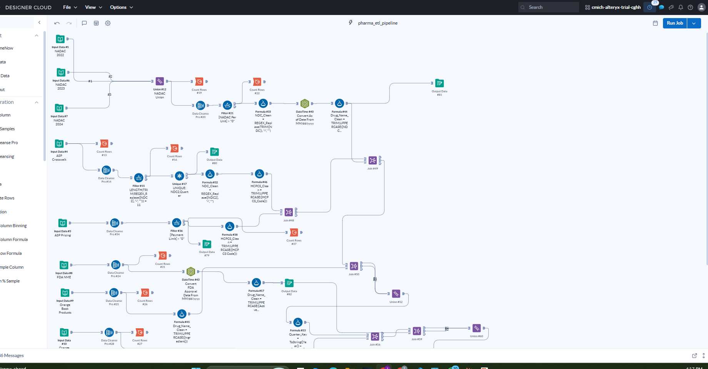

3.2 NADAC Ingest & Transform Stream (Top Lane)
Three NADAC yearly files (2022-2024) feed into Union #12, then flow through Data Cleanse Pro, Filter (NADAC Per Unit > 0), NDC_Clean formula, DateTime conversion, and Drug_Name_Clean standardization before joining.
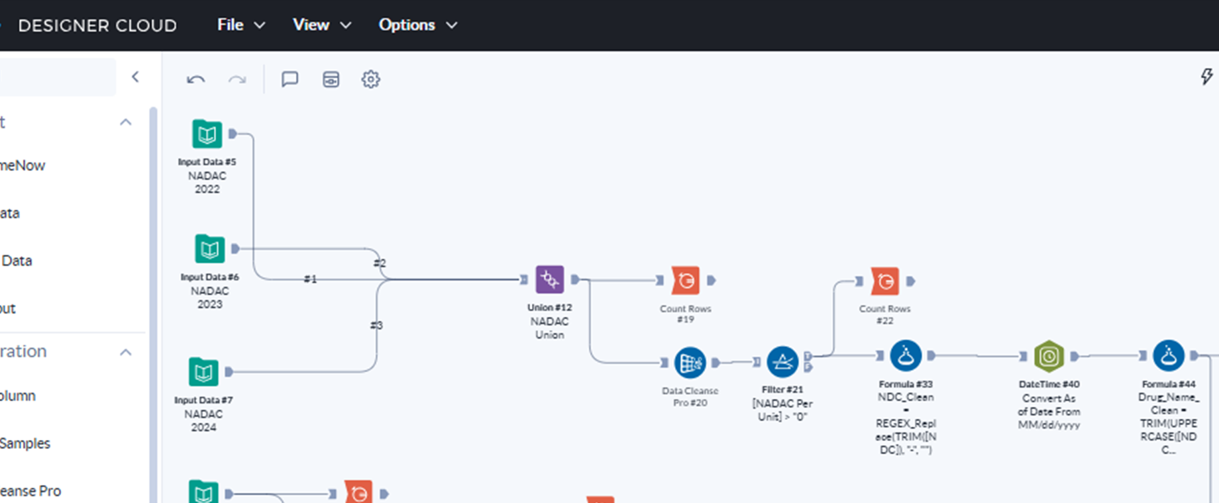

3.3 ASP Pricing, FDA & Join Convergence (Middle Section)
ASP Pricing and Crosswalk streams are validated and transformed separately, then joined on HCPCS_Clean. The FDA NME, Orange Book Products, Exclusivity, and PPI streams feed in through a series of left joins, with Union tools preserving all pricing rows even when FDA/PPI data is absent.
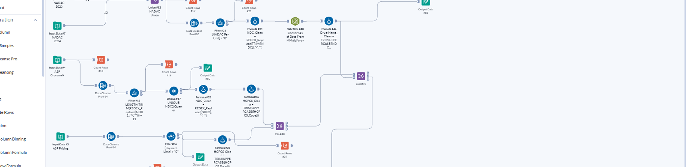

3.4 Enrichment & Load (Bottom Section)
The fully joined 109,552-row dataset flows through a Select tool (type corrections), then six enrichment Formula tools, a Sort and two Multi-Row Formula tools (YoY% and Rolling 4Q Avg), a Summarize+Join for Volatility CV, and finally Output Data #78 (Master.csv).
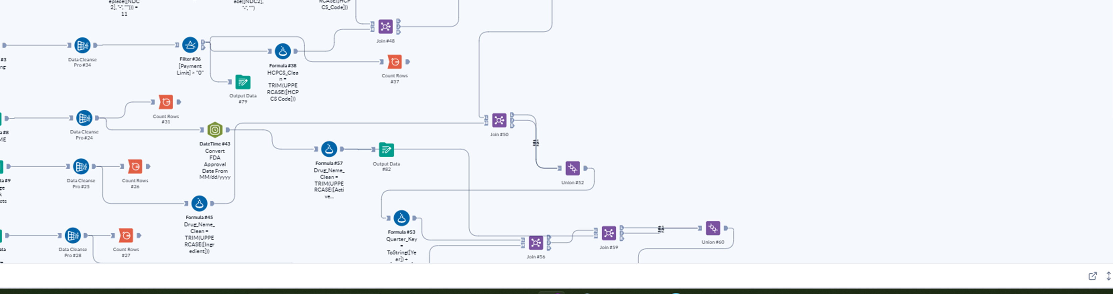

3.5 Pipeline Output Results
All six output CSV files were generated successfully in Alteryx Data Storage and downloaded locally. Job 3021950 completed at 3:44 PM with all outputs reporting Completed status.

File | Storage Location | Status
Master.csv | tfs://cmich-alteryx-trial-cghh/171496/Master.csv | Completed (11 sec)
ASP_Pricing.csv | tfs://cmich-alteryx-trial-cghh/171496/ASP_Pricing.csv | Completed (10 sec)
ASP_Crosswalk.csv | tfs://cmich-alteryx-trial-cghh/171496/ASP_Crosswalk.csv | Completed (10 sec)
NADAC.csv | tfs://cmich-alteryx-trial-cghh/171496/NADAC.csv | Completed (11 sec)
FDA_Reference.csv | tfs://cmich-alteryx-trial-cghh/171496/FDA_Reference.csv | Completed (10 sec)
PPI_Index.csv | tfs://cmich-alteryx-trial-cghh/171496/PPI_Index.csv | Completed (10 sec)

4. Phase-by-Phase Pipeline Documentation

Phase 1: Ingest
Nine Input Data tools load all source files from Alteryx Data Storage into the workflow.
Tool # | Label | Rows | Configuration
Input #5 | NADAC 2022 | ~51K | nadac_2022.csv — 16 columns, As of Date in M/D/YYYY format
Input #6 | NADAC 2023 | ~39K | nadac_2023.csv — headers normalized from underscore to spaces
Input #7 | NADAC 2024 | ~49K | nadac_2024.csv — original space-delimited headers
Input #4 | ASP Crosswalk | 52,398 | asp_crosswalk_combined.csv — 12 cols: HCPCS_Code, NDC2, Drug Name, Year, Quarter
Input #3 | ASP Pricing | 6,428 | asp_pricing_combined.csv — 12 cols: HCPCS Code, Payment Limit, Year, Quarter
Input #8 | FDA NME | 1,341 | nme_approvals_1985_2024.csv — 26 cols incl. Active Ingredient/Moiety, FDA Approval Date
Input #9 | Orange Book Products | 47,926 | products.csv — converted from tilde-delimited .txt — 14 cols incl. Ingredient, Appl_No, Type
Input #10 | Orange Book Exclusivity | 2,018 | exclusivity.csv — converted from tilde-delimited .txt — 5 cols: Appl_No, Exclusivity_Code, Exclusivity_Date
Input #11 | PPI | 309 | ppi_pharma.csv — 2 cols: observation_date, PCU4461104461101

NADAC Union (Tool #12)
- Type: Union tool connecting Input #5, #6, #7
- Configuration: Auto Config by Name — matches columns by name across all three files
- Output: 139,756 combined NADAC rows
- Fix applied: 2022 and 2023 files had underscore column headers vs spaces in 2024. Fixed via PowerShell header normalization before upload.

Phase 2: Validate
Each stream receives: Count Rows (baseline) → Data Cleanse Pro (null removal + whitespace trim) → Filter (business rule) → Count Rows (post-validation).

Validation Results Summary
Source | Raw Rows | Clean Rows | Dropped | Primary Filter
ASP Pricing | 6,428 | 6,418 | 10 | Payment Limit > 0
ASP Crosswalk | 52,398 | 35,384 | 17,014 | NDC length=11 + dedup
NADAC | 139,756 | 139,755 | 1 | NADAC Per Unit > 0
FDA NME | 1,341 | 1,341 | 0 | Null row removal
OB Products | 47,926 | 47,926 | 0 | Null row removal
OB Exclusivity | 2,018 | 2,018 | 0 | Null row removal
PPI | 309 | 309 | 0 | Null row removal

Key Filter Expressions
- ASP Crosswalk NDC validation (Filter #15): LENGTH(TRIM(REGEX_Replace([NDC2], "-", ""))) = 11
- Unique deduplication (Tool #17): Group By NDC2 + Quarter → 35,384 unique NDC-quarter pairs
- NADAC price filter (Filter #21): [NADAC Per Unit] > 0
- ASP price filter (Filter #36): [Payment Limit] > 0

Phase 3: Transform
Tool # | Type | Stream | Configuration
#32 | Formula | ASP Crosswalk | NDC_Clean = REGEX_Replace([NDC2], "-", "") — strips dashes for join key
#33 | Formula | NADAC | NDC_Clean = REGEX_Replace(TRIM([NDC]), "-", "") — same standardization
#38 | Formula | ASP Pricing | HCPCS_Clean = TRIM(UPPERCASE([HCPCS Code])) — standardize billing code
#39 | Select | PPI | Renamed PCU4461104461101 → PPI_Index; type changed V_String → Double
#40 | DateTime | NADAC | As of Date: input %m/%d/%Y → output As_of_Date_Clean (Date type)
#41 | DateTime | PPI | observation_date: input %Y-%m-%d → Date type for Quarter_Key derivation
#43 | DateTime | FDA NME | FDA Approval Date: input %m/%d/%Y → Approval_Date_Clean (Date type)
#44 | Formula | NADAC | Drug_Name_Clean = TRIM(UPPERCASE([NDC Description])) — for FDA join
#45 | Formula | OB Products | Drug_Name_Clean = TRIM(UPPERCASE([Ingredient])) — match ingredient names
#46 | Formula | ASP Crosswalk | HCPCS_Clean = TRIM(UPPERCASE([HCPCS_Code])) — match ASP Pricing format
#53 | Formula | Combined | Quarter_Key = ToString([Year]) + [Quarter] → e.g. '2023Q1'
#54 | Formula | PPI | Quarter_Key = DateTimeFormat([PPI_Date],"%Y")+"Q"+ToString(CEIL(ToNumber(DateTimeFormat([PPI_Date],"%m"))/3))
#57 | Formula | FDA NME | Drug_Name_Clean = TRIM(UPPERCASE([Active Ingredient/Moiety])) — for NADAC join
#65 | Select | All streams | Type corrections: Payment Limit, NADAC Per Unit, PPI_Index_Avg all set to Double

Phase 4: Enrich
Output Column | Tool | Formula / Logic
Gross_to_Net_Gap | Formula #66 | [Payment Limit] - [NADAC Per Unit] — dollar difference between Medicare reimbursement and retail acquisition cost
Gross_to_Net_Pct | Formula #67 | IIF([NADAC Per Unit]!=0, ([Payment Limit]-[NADAC Per Unit])/[NADAC Per Unit]*100, NULL()) — GTN gap as %
Inflation_Adj_Price | Formula #69 | IIF([PPI_Index_Avg]!=0, [Payment Limit]/[PPI_Index_Avg]*100, NULL()) — real-dollar price normalized by PPI
YoY_Pct | Sort #70 + Multi-Row #71 | Sort: NDC_Clean/Quarter/Year ASC. IIF([Row-1:NDC_Clean]=[NDC_Clean] AND [Row-1:Quarter]=[Quarter] AND [Row-1:Year]=[Year]-1, ([Payment Limit]-[Row-1:Payment Limit])/...*100, NULL())
Rolling_4Q_Avg | Multi-Row #72 (Rows=4) | IIF([Row-3:NDC_Clean]=[NDC_Clean], ([Payment Limit]+[Row-1:Payment Limit]+[Row-2:Payment Limit]+[Row-3:Payment Limit])/4, NULL())
Volatility_CV | Summarize #73 + Join #74 + Formula #77 | Summarize by NDC_Clean: Avg→Avg_Price, StdDev→StdDev_Price. Join back. CV = IIF([Avg_Price]!=0, [StdDev_Price]/[Avg_Price]*100, NULL())

Phase 5: Join
# | Tool | Left Input | Right Input | Join Key / Output
1 | Join #48 | ASP Pricing (6,418 rows) | ASP Crosswalk (35,384 rows) | HCPCS_Clean = HCPCS_Clean → 272,343
2 | Join #49 | Join 1 J (272,343) | NADAC (139,755 rows) | NDC_Clean = NDC_Clean → 165,248
3 | Join #50 + Union #52 | Join 2 J (165,248) | OB Products (47,926 rows) | Drug_Name_Clean (left join) → 165,248
4 | Join #56 + Union | Join 3 (165,248) | PPI Summarize (~33 qtrs) | Quarter_Key (left join) → 109,552
5 | Join #59 + Union #60 | Join 4 (109,552) | FDA NME (1,341 rows) | Drug_Name_Clean (left join) → 109,552
6 | Join #61 + Union #62 | Join 5 (109,552) | OB Exclusivity (2,018 rows) | Appl_No (left join) → 109,552 FINAL

Phase 6: Load
Output # | File | Rows | Source Stream
#78 | Master.csv | 109,552 | Formula #77 output — fully enriched, all 6 metrics
#79 | ASP_Pricing.csv | 6,418 | After Filter #36 (Payment Limit > 0)
#80 | ASP_Crosswalk.csv | 35,384 | After Unique #17 (NDC2 + Quarter dedup)
#81 | NADAC.csv | 139,755 | After Filter #21 (NADAC Per Unit > 0)
#82 | FDA_Reference.csv | 1,341 | After Drug_Name_Clean formula on FDA NME stream
#83 | PPI_Index.csv | ~33 | After Summarize #55 (quarterly PPI averages)

5. Errors Encountered and Fixes Applied
Error | Root Cause | Fix Applied
NADAC Union: column not in all inputs | 2022/2023 used underscore headers; 2024 used spaces | PowerShell: read header, replace underscores with spaces, write back
ASP: Invalid UTF-8 '\xA0' | Non-breaking spaces in Section 508 CSV files | PowerShell: read as bytes, replace 0xA0 with 0x20
ASP combined — wrong header row | 8-9 title rows precede actual column headers | PowerShell: index $lines[8] as header, data from $lines[9]
products.txt read as single column | Tilde (~) delimiter not recognized | PowerShell StreamReader/StreamWriter: split on ~, quote comma fields
DateTime: year out of range on As of Date | Input format set to %Y-%m-%d but data is M/D/YYYY | Changed input format to %m/%d/%Y
Join: Right_Column1 field missing | Join tool defaulted to generic Column1 field name | Manually set join: HCPCS_Clean = HCPCS_Clean
Union: Appl_No not in all inputs | L output lacks Orange Book columns from J output | Changed Union to Manual configuration
Multi-Row: Unknown variable Row-3:NDC_Clean | Number of Rows parameter set to 1 | Changed Number of Rows from 1 to 4
Summarize: no Average option for PPI_Index | PPI_Index column was V_String type | Changed type to Double in Select tool before Summarize

6. Output Dataset Schema

6.1 Master Tab (109,552 rows)
Column | Type | Description
HCPCS Code / HCPCS_Clean | String | Medicare billing code (raw and standardized)
NDC2 / NDC_Clean | String | National Drug Code (formatted and 11-digit plain)
Payment Limit | Double | Medicare ASP reimbursement rate per unit
NADAC Per Unit | Double | Retail pharmacy acquisition cost per unit
Year / Quarter | Int / String | Reporting period
Drug_Name_Clean | String | Standardized drug name (UPPERCASE TRIM)
PPI_Index_Avg | Double | Quarterly average PPI for pharma sector
Approval_Date_Clean | Date | FDA approval date (YYYY-MM-DD)
Gross_to_Net_Gap | Double | ASP Payment Limit minus NADAC Per Unit
Gross_to_Net_Pct | Double | GTN gap as % of NADAC price
Inflation_Adj_Price | Double | Payment Limit normalized by quarterly PPI index
YoY_Pct | Double | Year-over-year % change in Payment Limit per NDC/Quarter
Rolling_4Q_Avg | Double | 4-quarter rolling average of Payment Limit per NDC
Volatility_CV | Double | Coefficient of variation (StdDev/Mean*100) per NDC

7. Next Steps: Project 1 Dashboards
# | Dashboard | Tool | Key Metrics
1 | Drug Price Trend | Power BI | ASP Payment Limit over time by drug, YoY%, Rolling_4Q_Avg
2 | Gross-to-Net Analysis | Power BI | Gross_to_Net_Gap, Gross_to_Net_Pct by drug class and quarter
3 | Inflation-Adjusted Pricing | Tableau | Inflation_Adj_Price vs nominal price, PPI_Index_Avg trend
4 | Drug Volatility Heatmap | Tableau | Volatility_CV by drug and therapeutic area
5 | FDA Approval Timeline | Power BI | NME approvals by year, brand vs generic, exclusivity periods
6 | Executive Summary KPIs | Excel | Summary cards: avg GTN%, top volatile drugs, YoY movers

End of Report

